Lê Thị Huỳnh Như – PC09147

**LAB 1 -COM2012**

**Câu 1:**

CSDL Northwind gồm các bảng sau:

1. Table Customer

|  |  |
| --- | --- |
| Field Name | Data Type |
| **ID** | AutoNumber |
| Company | Text |
| Last Name | Text |
| First Name | Text |
| E-mail Address | Text |
| Job Title | Text |
| Business Phone | Text |
| Home Phone | Text |
| Mobile Phone | Text |
| Fax Number | Text |
| Address | Memo |
| City | Text |
| State/Province | Text |
| ZIP/Postal Code | Text |
| Country/Region | Text |
| Web Page | Hyperlink |
| Notes | Memo |
| Attachments | Attachment |

1. Table Employee

|  |  |
| --- | --- |
| Field Name | Data Type |
| **ID** | AutoNumber |
| Company | Text |
| Last Name | Text |
| First Name | Text |
| E-mail Address | Text |
| Job Title | Text |
| Business Phone | Text |
| Home Phone | Text |
| Mobile Phone | Text |
| Fax Number | Text |
| Address | Memo |
| City | Text |
| State/Province | Text |
| ZIP/Postal Code | Text |
| Country/Region | Text |
| Web Page | Hyperlink |
| Notes | Memo |
| Attachments | Attachment |

1. Table Orders

|  |  |
| --- | --- |
| Field Name | Data Type |
| **Order ID** | AutoNumber |
| Employee ID | Number |
| Customer ID | Number |
| Order Date | Date/Time |
| Shipped Date | Date/Time |
| Shipper ID | Number |
| Ship Name | Text |
| Ship Address | Memo |
| Ship City | Text |
| Ship State/Province | Text |
| Ship ZIP/Postal Code | Text |
| Ship Country/Region | Text |
| Shipping Fee | Currency |
| Taxes | Currency |
| Payment Type | Text |
| Paid Date | Date/Time |
| Notes | Memo |
| Tax Rate | Number |
| Tax Status | Number |
| Status ID | Number |

1. Table Invoices

|  |  |
| --- | --- |
| Field Name | Data Type |
| **Invoice ID** | AutoNumber |
| Order ID | Number |
| Invoice Date | Date/Time |
| Due Data | Date/Time |
| Tax | Currency |
| Shipping | Currency |
| Amount Due | Currency |

1. Table Order Details

|  |  |
| --- | --- |
| Field Name | Data Type |
| **ID** | Auto Number |
| Order ID | Number |
| Product ID | Number |
| Quantity | Number |
| Unit Price | Currency |
| Discount | Number |
| Status ID | Number |
| Date Allocated | Date/Time |
| Purchase Order ID | Number |
| Inventory ID | Number |

1. Table Sales Reports

|  |  |
| --- | --- |
| Field Name | Data Type |
| **Group By** | Text |
| Display | Text |
| Title | Text |
| Filter Row Source | Memo |
| Default | Yes/No |

1. Table Purchase Orders

|  |  |
| --- | --- |
| Field Name | Data Type |
| **Purchase Order ID** | AutoNumber |
| Supplier ID | Number |
| Created By | Number |
| Submitted Date | Date/Time |
| Creation Date | Date/Time |
| Status ID | Number |
| Expected Date | Date/Time |
| Shipping Fee | Currency |
| Taxes | Currency |
| Payment Date | Date/Time |
| Payment Amount | Currency |
| Payment Method | Text |
| Notes | Memo |
| Approved By | Number |
| Approved Date | Date/Time |
| Submitted By | Number |

**Câu 2**:

Chụp hình cài đặt MySQL

1. Ảnh màn hình welcome MySQL Workbench

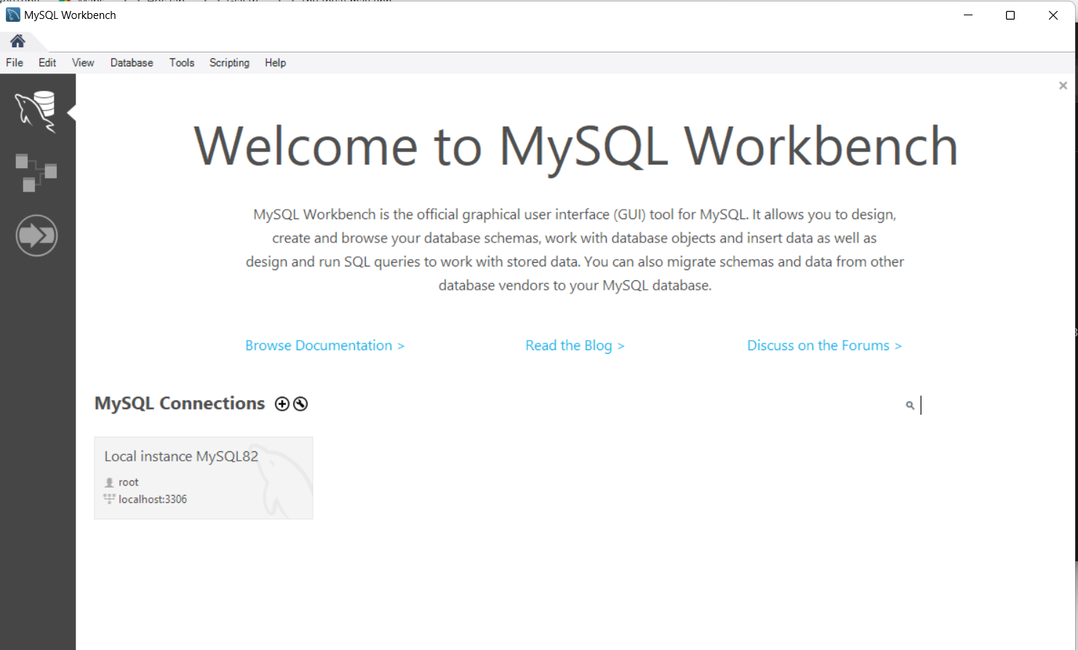

2. Ảnh khi đăng nhập password root

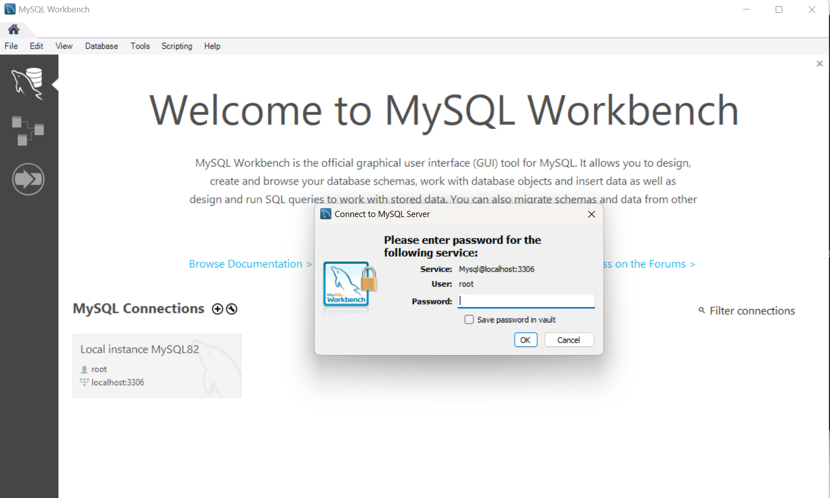

3. Ảnh khi vào thành công giao diện chính MySQL Workbench

